[XML](https://abhiandroid.com/ui/xml/" \o "XML in Android" \t "_self) stands for Extensible Markup Language. [XML](https://abhiandroid.com/ui/xml/) is a markup language much like [HTML](https://abhiandroid.com/ui/html/) used to describe data.  [XML](https://abhiandroid.com/ui/xml/) tags are not predefined in XML. We must define our own Tags. Xml as itself is well readable both by human and machine. Also, it is scalable and simple to develop. In Android we use xml for designing our layouts because xml is lightweight language so it doesn’t make our layout heavy.

**Different XML Files Used in Android:**

In Android there are several xml files used for several different purposes. Below we define each and every one.

**1. Layout XML Files:**Layout xml files are used to define the actual UI(User interface) of our application. It holds all the elements(views) or the tools that we want to use in our application. Like the [TextView](https://abhiandroid.com/ui/textview/" \o "TextView" \t "_self)’s, [Button](https://abhiandroid.com/ui/button/)’s and other UI elements.

**Location in Android Studio:**

You will find out this file inside the **res** folder and inside it there is another folder named **layout** where you will get all the layout files for their respective activities or fragments.

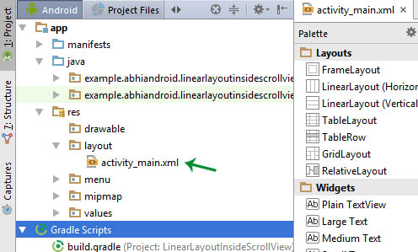

**2. Manifest xml File(Mainfest.xml):**This xml is used to define all the components of our application. It includes the names of our application packages, our Activities, receivers, services  and the permissions that our application needs. For Example – Suppose we need to use internet in our app then we need to define Internet permission in this file.

**Location in Android Studio:**

It is located inside app > manifests folder

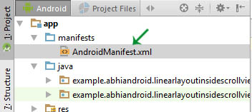

**3. Strings xml File(strings.xml):**This xml file is used to replace the Hard-coded strings with a single string. We define all the strings in this xml file and then access them in our app(Activity or in  Layout XML files) from this file. This file enhance the reusability of the code.

**Location in Android Studio:**

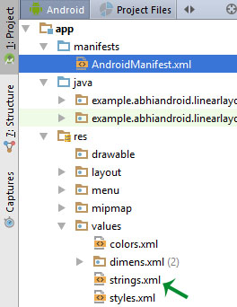

**4. Styles xml File(styles.xml):**This xml is used to define different styles and looks for the UI(User Interface) of application. We define our custom themes and styles in this file.

**Location in Android Studio:**

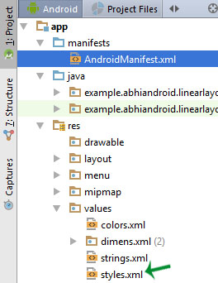

**5. Drawable xml Files:**These are those xml files that are used to provide various graphics to the elements or views of application. When we need to create a custom UI we use drawable xml files. Suppose if we need to define a gradient color in the background of [Button](https://abhiandroid.com/ui/button/) or any custom shape for a view then we create a Drawable xml file and set it in the background of View.

**6. Color xml File (colors.xml):**This file is used to define the color codes that we used in our app. We simply define the color’s in this file and used them in our app from this file.

**Location in Android Studio**

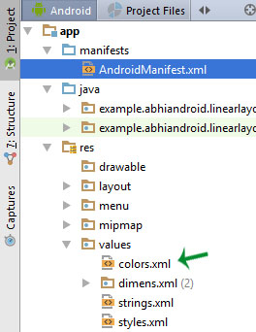

**7. Dimension xml File(dimens.xml):**This xml file is used to define the dimensions of the View’s. Suppose we need a Button with 50dp(density pixel) height then we define the value 50dp in dimens.xml file and then use it in our app from this file.

**Location in Android Studio:**

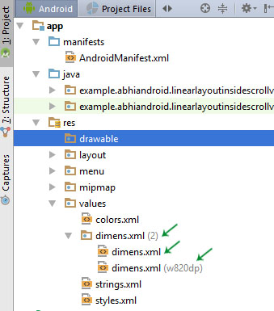

**AndroidManifest.xml file**

Every app project must have an AndroidManifest.xml file, with precisely that name, at the root of the [project source set](https://developer.android.com/studio/build#sourcesets). The manifest file describes essential information about your app to the Android build tools, the Android operating system, and Google Play.

* It is **responsible to protect the application** to access any protected parts by providing the permissions.
* It also **declares the android api** that the application is going to use.
* It **lists the instrumentation classes**. The instrumentation classes provides profiling and other informations. These informations are removed just before the application is published etc.

The code snapshot of androidmanifest.xml-

*<?***xml version="1.0" encoding="utf-8"***?>*<**manifest xmlns:android="http://schemas.android.com/apk/res/android"  
 xmlns:tools="http://schemas.android.com/tools"**>  
 <**application  
 android:allowBackup="true"  
 android:dataExtractionRules="@xml/data\_extraction\_rules"  
 android:fullBackupContent="@xml/backup\_rules"  
 android:icon="@mipmap/ic\_launcher"  
 android:label="@string/app\_name"  
 android:supportsRtl="true"  
 android:theme="@style/Theme.MyApplication"  
 tools:targetApi="31"**>  
 <**activity  
 android:name=".MainActivity2"  
 android:exported="false"** />  
 <**activity  
 android:name=".MainActivity"  
 android:exported="true"**>  
 <**intent-filter**>  
 <**action android:name="android.intent.action.MAIN"** />  
  
 <**category android:name="android.intent.category.LAUNCHER"** />  
 </**intent-filter**>  
 </**activity**>  
 </**application**>  
  
</**manifest**>

## **Elements of the AndroidManifest.xml file**

The elements used in the above xml file are described below.

#### **<manifest>**

**manifest** is the root element of the AndroidManifest.xml file. It has **package** attribute that describes the package name of the activity class.

<application>

**application** is the subelement of the manifest. It includes the namespace declaration. This element contains several subelements that declares the application component such as activity etc.

The commonly used attributes are of this element are **icon**, **label**, **theme** etc.

**android:icon** represents the icon for all the android application components.

**android:label** works as the default label for all the application componen

**android:theme** represents a common theme for all the android activities.

#### **<activity>**

**activity** is the subelement of application and represents an activity that must be defined in the AndroidManifest.xml file. It has many attributes such as label, name, theme, launchMode etc.

**android:label** represents a label i.e. displayed on the screen.

**android:name** represents a name for the activity class. It is required attribute.

<intent-filter>

**intent-filter** is the sub-element of activity that describes the type of intent to which activity, service or broadcast receiver can respond to.

<action>

It adds an action for the intent-filter. The intent-filter must have at least one action element.

<category>

It adds a category name to an intent-filter.

**Components of an Android Application**

There are some necessary building blocks that an Android application consists of. These loosely coupled components are bound by the application manifest file which contains the description of each component and how they interact.

There are the following main components of an android app:

1. Activities

Activities are said to be the presentation layer of our applications. The UI of our application is built around one or more extensions of the Activity class. By using Fragments and Views, activities set the layout and display the output and also respond to the user’s actions. An activity is implemented as a subclass of class Activity.

public class MainActivity extends AppCompatActivity {  
  
 }

2. Services

Services are like invisible workers of our app. These components run at the backend, updating your data sources and Activities, triggering Notification, and also broadcast Intents. They also perform some tasks when applications are not active. A service can be used as a subclass of class Service:

public class ServiceName extends Service {

}

3. Content Providers

It is used to manage and persist the application data also typically interacts with the SQL database. They are also responsible for sharing the data beyond the application boundaries. The Content Providers of a particular application can be configured to allow access from other applications, and the Content Providers exposed by other applications can also be configured.

A content provider should be a sub-class of the class ContentProvider.

public class contentProviderName extends ContentProvider {

public void onCreate(){}

}

4. Broadcast Receivers

They are known to be intent listeners as they enable your application to listen to the Intents that satisfy the matching criteria specified by us. Broadcast Receivers make our application react to any received Intent thereby making them perfect for creating event-driven applications.

5. Intents

It is a powerful inter-application message-passing framework. They are extensively used throughout Android. Intents can be used to start and stop Activities and Services, to broadcast messages system-wide or to an explicit Activity, Service or Broadcast Receiver or to request action be performed on a particular piece of data.

6. Widgets

These are the small visual application components that you can find on the home screen of the devices. They are a special variation of [Broadcast Receivers](https://www.geeksforgeeks.org/broadcast-receiver-in-android-with-example/) that allow us to create dynamic, interactive application components for users to embed on their Home Screen.

7. Notifications

Notifications are the application alerts that are used to draw the user’s attention to some particular app event without stealing focus or interrupting the current activity of the user. They are generally used to grab user’s attention when the application is not visible or active, particularly from within a Service or Broadcast Receiver. Examples: E-mail popups, Messenger popups, etc.